Digital Technologies & Hangarau Matihiko 3.1

Level 3, 3 Credits, Internal Assessment

Student Documentation

This document serves as evidence of your work for **AS 91901: Apply user experience methodologies to develop a design for a digital technologies outcome**

# Instructions

Edit the header and replace the underlines with your full name and NSN (you can find this on PCSchools under Student Information).

You must attach relevant images (wireframes, mock-ups, screenshots, etc.) into each section of the document. You must also include a high-resolution copy of these images separately.

For your **FINAL** submission, make sure you have included:

1. Your name and National Student Number (NSN) in the header for each page
2. **ONLY** include the information you wish to have marked and moderated

Table of Contents

Instructions 1

Explain the purpose of the digital technologies outcome and the requirements of the end users 2

Explain relevant implications 4

Investigate relevant user experience methodologies 6

Iteration 1 - Colour Schemes & Font Pairings 7

Iteration 2 – Mock-up Designs 10

Iteration 3 – Final Iteration and Designs 13

Explain the appropriateness of a chosen design 16

Evaluate how the design addresses relevant implications 17

Justify that the chosen design is suitable for the purpose and end users 18

Justify how the chosen design might be further developed in the future 18

Appendix 19

# ­­Explain the purpose of the digital technologies outcome and the requirements of the end users

## Purpose

Write the communicative purpose of the outcome in the field below.

|  |
| --- |
| The communication purpose of my Spaced Repetition Website is to inform and educate the students and families of Onslow College about the College's **history**, its surrounding **whenua** (area), the **people** who contribute to it, and what Onslow College contributes back to the **community**. This should all be done using in an engaging manor using some sort of Spaced Repetition Software such as flash cards. |

## Identify stakeholders

You need to identify your end users. Fill in the table below with the end users you have identified, including whether that person/group is a primary stakeholder (usually the project owner), secondary stakeholder, and/or end-users.

|  |  |
| --- | --- |
| **Individuals / Group names** | **Role (i.e. end user, stakeholder, owner, etc.)** |
| Teachers at Onslow College | End User |
| Students at Onslow College | End Use |
| Parents of Students | End User |
| International Students | End User |
|  |  |
|  |  |
| James Robiony-Rogers (Myself) | Owner, Stakeholder & End User |
| Jaesan Ryfle-Turi | Potential Stakeholder & End User |
| Shakeel Morar | Potential Stakeholder & End User |

## Stakeholder requirements

Identify the stakeholder’s requirements through **surveys**, **interviews**, and **usability testing**.

To get my stakeholder requirements our class all created surveys with a range of questions about the end outcome. These served were then compiled into one and answered by a stakeholder. Here are the results of this.

### Functionality

We are required to have a total of 5 quizzes/lessons

* Each quiz question must have a: question, 1 correct answer with 2 incorrect answers
* Each quiz topic must have a total **question pool** of 15 questions
* The quiz will randomly pick 10 of those questions to be presented during each round
  + 5 Multi Choice & 5 Text Based
* ­­­­A high-score will be recorded and saved to the database along with a user’s initials/name
  + Only store the top 100 scores for each quiz along with time and date. Display on site

Needs to be coded according to Spaced Repetition Software conventions

* If a user gets a question wrong, it's added to the back of the queue to be asked again later
* Only questions answered correctly on the first try are scored
* Students need to be made aware of the questions they got wrong, along with the correct answer

### Design (visuals)

* Onslow College branding/colour scheme is not necessary but won’t be disallowed.
* Prefer a more serious and/or professional tone to the website
* The website needs to be accessible. Low-vision users should be able to access the data and use the quizzes
* The fonts should be accessible as well. We need to reduce the difficulty for students with dyslexia as much as possible
* Text must be sufficiently legible

### Data

* Questions and answers will be supplied along with some images
* The focus of the website should be the information and the quiz in equal parts, not one over the other

### Technological

* You may host your website on Pricilla or by your own means as long as its accessible

### Budget

* Free / Self-Financed (student made)

# Explain relevant implications

What relevant implications do you need to consider in the design of your digital technologies outcome? Explain at least three relevant implications and how they relate to your project.

## Intellectual property

Another thing I need to think about while creating my website is how I’m going to avoid using someone else's intellectual property. According to <https://en.wikipedia.org/wiki/Intellectual_property> “Intellectual property is a category of property that includes intangible creations of the human intellect.” Websites often include images and other forms of intellectual property in order to give it a more appealing aesthetic design. If the website is not aesthetically appealing, our users will be less inclined to use it and may find it difficult to navigate.

The purpose of my website will be to educate students, parents and teachers about Onslow College’s history, the surrounding whenua (land), local iwi, and Te-Reo Māori terms in an interactive manner. While designing and developing this website I must consider whether or not I could be using images that belong to somebody else, meaning it’s their intellectual property. If I did not take this into consideration, I could be facing legal concerns later down the track to do with copyright and or other legal infringements.

To ensure my site does not use anybody's intellectual property that I do not have the right to use, I will only use assets sourced from creative commons outlets such as [undraw.co/illustrations](https://undraw.co/illustrations), [fonts.google.com](https://fonts.google.com/), content I have a licence for or content produced by myself. This will mean every image, illustration, font etc. will either have a licence stating I am aloud to use the asset associated with it or will by my property, meaning I have free range of use. I will also have to make sure I credit the source to the extent the licence outlines. I will also provide links in the code to each of the places I have sourced the images, illustrations, fronts, etc. in order to prove they are free to use and distribute.

## Accessibility

According to the [Cambridge Dictionary](https://dictionary.cambridge.org/dictionary/english/accessibility), Accessibility is “the fact of being able to be reached or obtained easily” as well as “the quality of being easy to understand”. This means that if a website has accessibility they take into consideration people of all different abilities. This means taking into consideration those with a range of colour blindness as well as those who may have low vision.

Throughout the design and development process I must consider the user experience for individuals who have impearled senses. If I were not to take these factors into consideration while developing my outcome I could be excluding individuals who need to use my outcome but cannot, due to their impairment.

To ensure my website caters for those with different abilities, I will make sure the colour scheme I develop is suitable for those potential uses with a range of different colour blindness. The way I will carry this out is through [Adobe Colour’s Accessibility Tool](https://color.adobe.com/create/color-accessibility), which simulates what a range of different colour blind conditions perceive your colour scheme as, as well as their contrast checker.

Secondly, in order to cater for those potential uses with low vision I will make sure that I am tagging each and every image on my site with an appropriate alt tag so that those people are able to use a text to speech program if necessary.

And lastly, if I have enough time, I will look to develop a toggleable dark mode for those people that are light sensitive and need to use inverted colours in order to read and use websites comfortably

## Aesthetics / Usability

Lastly, while creating my website I will also need to consider the usability and aesthetics of the site. According to [www.techopedia.com](http://www.techopedia.com/) "Usability is the degree of ease with which products such as software and Web applications can be used to achieve required goals effectively".  In a website usability is a very important aspect, if users cannot navigate and use the site effectively the purpose of that site therefore becomes redundant as there’s a lack of usability.

It is vitally important that this site is usable. If it were not, students (and users in general) would be less inclined to use it no matter how helpful the content is. This could mean students miss out on beneficial content.

In order to ensure my website is usable I will need to follow key design conventions such as simplicity and minimal design, consistency and standards throughout all the pages of the site. This will mean that users will not be bombarded with a million different things to click on but rather just the key functions of the site. This means users will become familiar with the site's layout rather quickly, therefore leading to efficient use and optimisation of the user’s time and efforts. In order to make sure that my site is usable, I will conduct usability testing with potential uses of the site, such as past, present and/or future Onslow Students as well as any other potential end user. This will allow me to improve the site and fix any usability issues that I may have missed or overlooked.

# Investigate relevant user experience methodologies

You need to investigate and use relevant user experience methodologies to generate, evaluate, and improve your design. UX methodologies include (but are not limited to):

|  |  |
| --- | --- |
| * user research * usability evaluation * information architecture * user interface design | * interaction design * visual design * content strategy * accessibility |

Identify the user experience methodologies you will use. For each, justify why the user experience methodology is relevant to the outcome of your design.

## Methodology 1: User Interface Design

During the design process, I have used UI Design tools such as wireframes, mock-ups, and sitemaps in order to visualise designs of the outcome.

Mock-ups proved to be a very effective way to show how a colour scheme and font combination came together on a website and what the result of it looked like. Additionally, the mock-ups were also used for accessibility and usability testing where I gathered feedback around the looks and feel, legibility of text and colour contrast. This feedback would later be used to further refine the design.

The UI Design process was a necessary step in designing the outcome as the site is a user interface. It is necessary to design the look and feel of the website around the required functionality. Due to the usability and accessibility testing made possible through the UI Design process, the final design is a direct product of it.

## Methodology 2: Interaction Design

Another methodology I needed to focus on during the design process was Interaction Design. I performed useability testing and gathered feedback. Based on the feedback I further refined the interaction as to make it more intuitive for the user. The final design is the result of going back and forth usability testing, refining interaction.

Interaction Design is a necessary methodology to focus on during the development process. It is necessary to get the interaction between user and website correct because failing to do so results in the website becoming unusable, consequently failing to fulfilling the purpose.

## Methodology 3: Accessibility

In my design, Accessibility was one of the other key methodologies I focused on. I performed contrast and colourblind testing on my colour scheme to make sure that the colours were suitable for a all users. Based on the feedbacked gathered across my 3 iterations of designs, it proved successful as fewer relating to colour contrast and font size were identified for each iteration. The final design does not have any issues and has a consistent text-to-background contrast ratio of 13.46 : 1

Accessibility is a necessary methodology to use while developing a site and especially in this case. The outcome is intended for students of Onslow Collage who have a wide range of accessibility needs. There are students that experience vision impairments such as low vision, varying degrees of colour blindness as well as students who experience reading difficulties such as dyslexia. Studying practices designed to improve the accessibility of a site, I was able to choose fonts and style them in a they that is suitable for a range of users to read. I was also able put together a colour scheme for that works for a range of colour blind users.

# Iteration 1 - Colour Schemes & Font Pairings

Attach your website design images here. Alternatively, attach images to the appendix. Provide high-quality copies with the final submission.

## Design Idea 1

**Colour Schemes:**  Focusing the red and green on the accents of the website

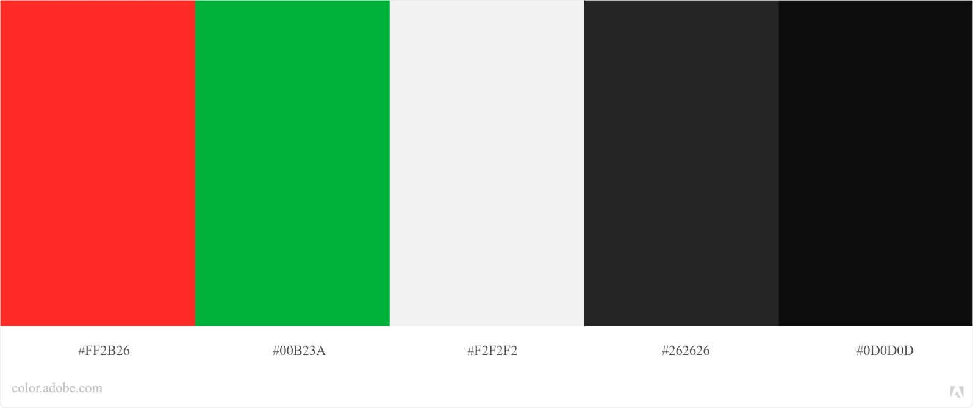

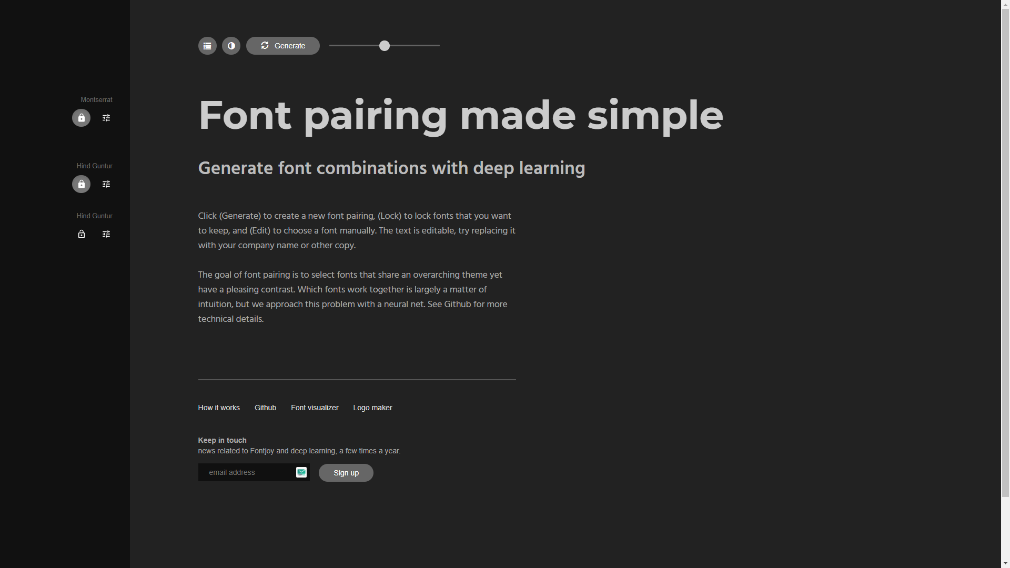

**Font Pairings Include:** Montserrat & Hind or Hind Guntur *(of varying weights)*

#### *Testing / Feedback*: Shakeel Morar

Looking over the colour scheme above I really like the vibrancy of the red and yellow colours, however do not think that these would quite work as the accents throughout the website. I reckon that they would be better suited for maybe something like a tick and cross that indicates how a student has answered a question or how well they have performed during a quiz (Correct/Incorrect and Pass/Fail maybe)

#### How will you use this feedback to improve the outcome?

I will be taking Shakeel’s feedback on board about the vibrancy of the green and red. Having another look at these shades on one of the wireframe mock-ups I have realised that using them as an indicator accent (indicator accent meaning an accent for a correct/incorrect icon for example) would be a really good idea as the colour is slightly separate from the rest of the websites colour scheme and therefore means it can stand out better.

## Design idea 2

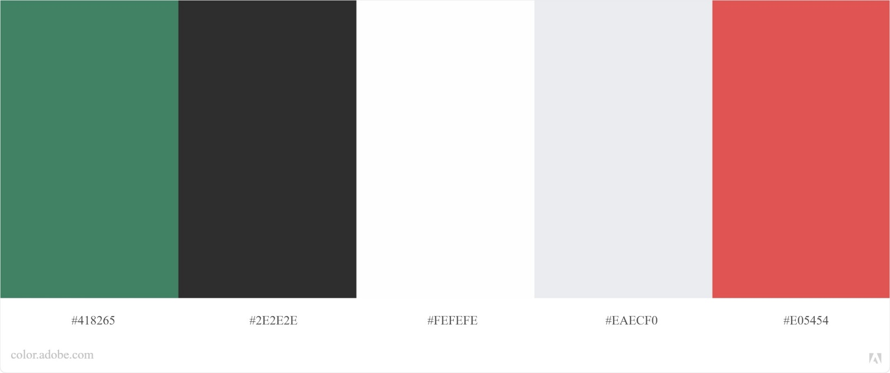

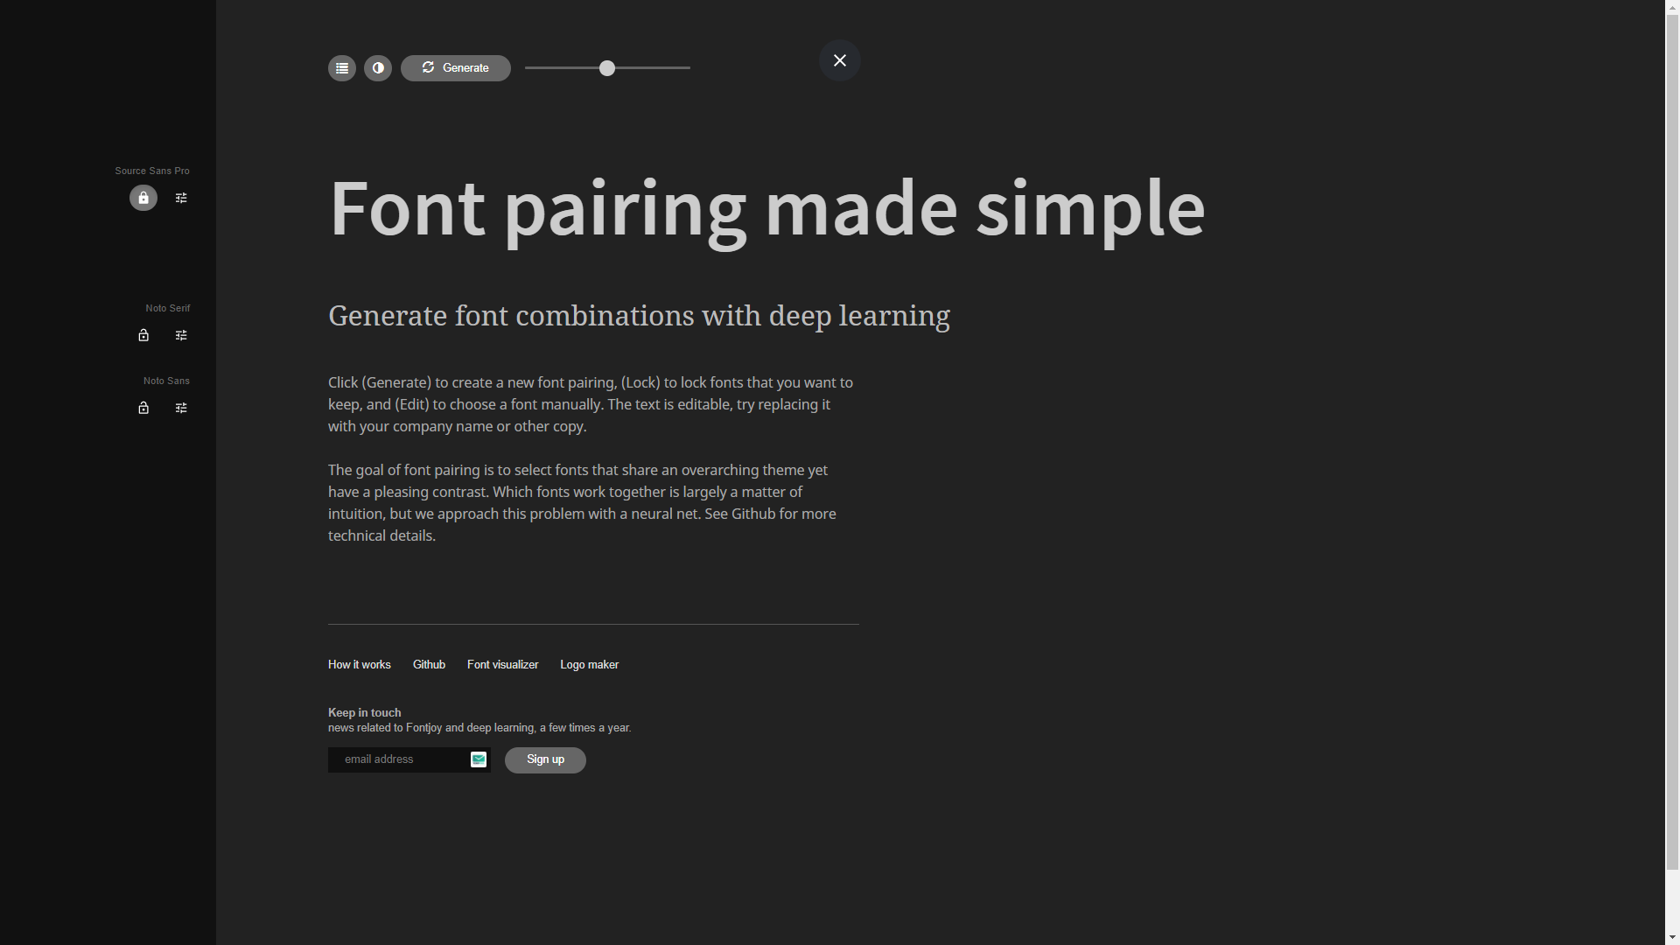

**Font Pairing Includes:** Source Sans Pro, Noto Serif & Noto Sans

#### *Testing / Feedback*: Daniel Stevens

After taking a good look at your 2nd colour scheme and font combination I can see that you’ve gone for more of a matte look with the colours, which I quite like the look of. I think that the green and red that you’ve chosen could be pulled off quite well as accent colours. As for the font combinations, I really like Montserrat, the one you used in your last pairing. It is a very clear and conveying font face. As for this pairing I do not really think that the Serif font you’ve used for the headers is the best choice for this kind of project. But similar to Montserrat, Source Sans Pro and Noto Sans look like really good choices. They are both clear very clear font faces and will allow everyone to be able to read them.

#### How will you use this feedback to improve the outcome?

As for this feedback I will use it to further refine my colour scheme and font pairing towards the final scheme and pair. After looking over the wireframe mock-up that is using this combination of fonts I fully agree with Shakeel. I do not believe that the Serif font style would be the best suit for this website as it projects more of a professional and formal tone where as I am not looking to go in this direction. I agree that the Sans font style is the clear decision for the website.

As for the colour scheme I think that I will go inevitably go for something that is similar to the “matte look” in my final scheme due to the fact that both this and my third colour scheme seem to follow a similar look. This does not mean however that the more vibrant green and red from the previous colour scheme will be binned.

## Design idea 3

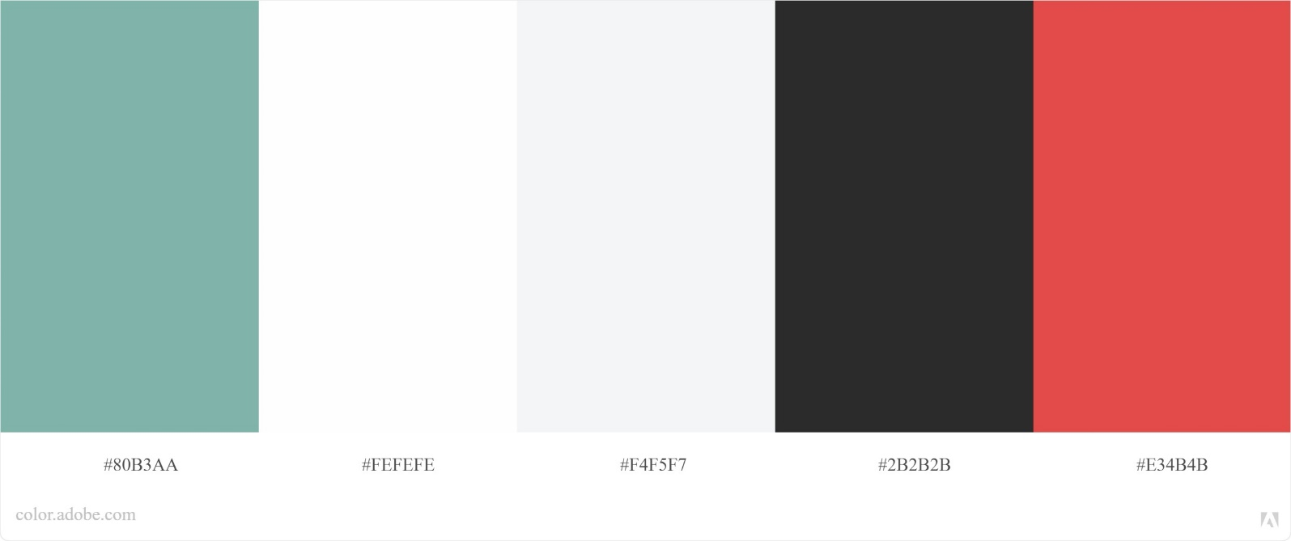

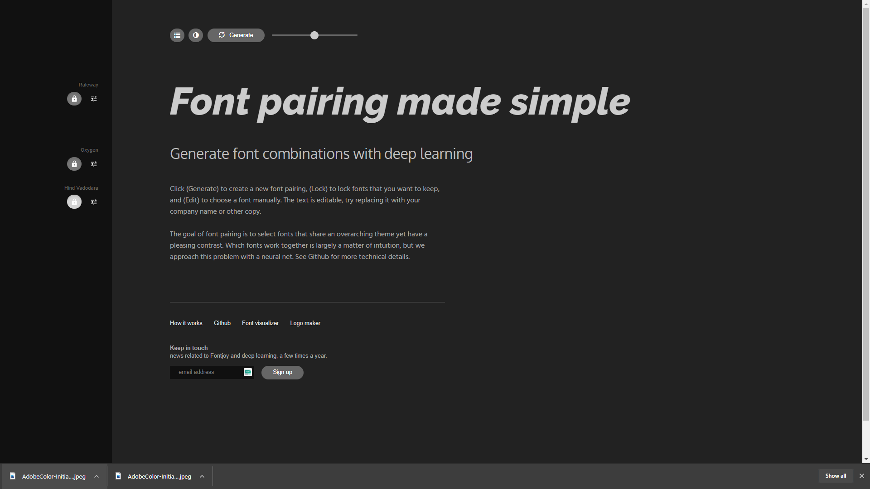

**Font Pairing Includes:** Railway, Oxygen & Hind Vadodara

#### *Testing / Feedback*: Callum Stevens

Just like your previous colour scheme I can see clearly like the pastel/matte look. You definitely have a nice range of colours to use on the site. In my opinion, I do not think that the green accent on the far left would fit the website as it is a bit too far from the Onslow College green and considering this is an Onslow College website you should have colours that are similar to that of the schools. Other than that the only thing that I could give feedback on is to make sure that the dark greys and off whites are of a shade that contrast well on top of each other. You’ll need to do some testing to work out if they are suitable.

As for the font combinations, I don’t particularly think anyone is better than the other. All I think is that you should stick to Sans type fonts as they seem to fit better with the intended tone of your website and are more widely readable.

#### How will you use this feedback to improve the outcome?

Thanks to Callum’s feedback I can now work on a developed colour scheme and final font combination. I have decided that I will follow Shak’s advice with using Sand type fonts and will base my final font combination on that.

I will also make sure to do dome contrast testing as to make sure that the colours I have chosen in my final colour scheme all work together and are easily readable. I am sure that there are some websites online that can help me with this process so I will also research if there are some I can use

# Iteration 2 – Mock-up Designs

## Design idea 1

#### *Testing / Feedback*: Shakeel Morar

Starting at the lessons page I really like the cards idea however I think that you could develop the way you design them a wee bit more. These currently look very amateur. As for the results page I can see that you’re using the Onslow colours from your first colour scheme. Please do not design a table like this, it does not fit the website. Your quiz cards on the other hand look very good, and I appreciate the little correct/incorrect indication in the bottom right corner.

#### How will you use this feedback to improve the outcome?

Thanks to Shak’s feedback I will now work on developing the lessons and results pages in order to make them more appealing and useable.

## Design idea 2

#### *Testing / Feedback*: Nerissa Linwood

The lesson page looks better than your previous design and I like how you’ve got the intentions to add images. As for the results page I think that the design of the table looks quite nice, but the colour scheme needs to be change from the accents to something more neutral.

Looking at the quiz questions pages, just like Shakeel, I really like the current/incorrect indicators that will show after you’ve answered a question. I also really like the simplistic and clam look of these pages, I’d suggest keeping these in your final design.

#### How will you use this feedback to improve the outcome?

Thanks to Nerissa’s feedback I think I the consensus will be that the quiz question pages should be here to stay as they are simplistic and serve its purpose.

## Design idea 3

#### *Testing / Feedback*: Tyler Rowe

In my opinion, I do not think that the red gradient goes well as a background. If I were to suggest something as a background, I’d suggest using one of those blurry neutral glassy backgrounds in order to provide a wee bit of depth without overwhelming the user.

Just like the others I really like how the quiz question pages have come out.

#### How will you use this feedback to improve the outcome?

Thanks to Nerissa’s feedback I think I the consensus will be that the quiz question pages should be here to stay as they are simplistic and serve its purpose.

# Iteration 3 – Final Iteration and Designs

Attach your website design images here. Alternatively, attach images to the appendix. Provide high-quality copies with the final submission.

## Final Colour Scheme & Font Pairing

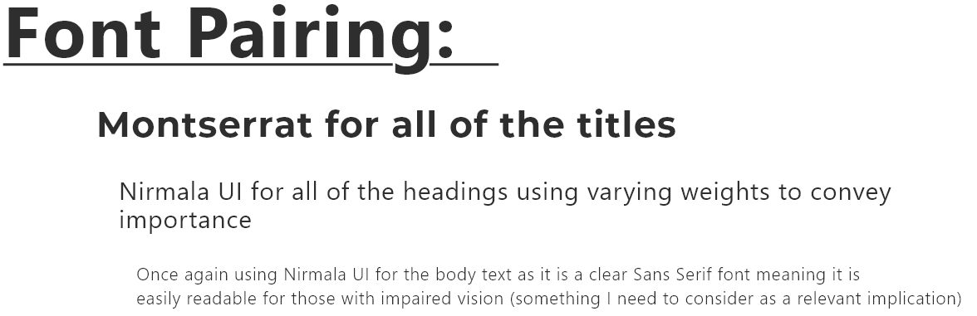

For my final iterated design, I have taken the feedback provided by Shakeel, Daniel and Callum and produced a final Font Pairing and Colour Scheme.

For the Font Pairing, I have decided to go with **Montserrat** as the title font, it’s very clear and received positive comments during feedback. As for the heading and body text I have decided to go with a widows’ font called [Nirmala UI](https://docs.microsoft.com/en-gb/typography/font-list/nirmala-ui). I found this that I liked the look of this font the most out of all the rest of the Sans Serif fonts. Since it’s a Windows font and is not on Google or Adobe fonts I will need to source the licence as to follow relevant implications and include the font in the websites package in order to be able to use it.

As for the Colour Scheme, I have passed the colours through Adobe Colour’s Contrast Checker to make sure that the colour combinations are fit for purpose. After some minor changes I have developed the final Colour Scheme for the website which is shown above. As for the Graphical Component colours, I have had to slightly darken the vibrant green to **#00AB39** for it to pass Adobe’s Graphical Component Contrast Check. The vibrant red (**#FF2B26**) on the other hand passed without change.

## Final Mock-up / Design

#### Home page

For my final Mock-up / Design I have gone through some iterative development and come up with a carousel design for the Lesson Cards. I am intending to have about 3 or 4 (4 in the this design) cards shoring at a time and for them to be scrollable letting the user choose which quiz they want to the do. The carousel should also have an auto feature where it will scroll to the next card every so often.

#### Quiz Question pages

As for the quiz question cards, they have remained relatively the same as the consensus was that they are all good and should be used in the final design.

#### Results page

Then finally moving onto the results page, which could be subject to change during the development stage, however I have kept the style of table as feedback suggested but changed the colour scheme from using both accent colours to using a single accent and a darker neutral colour as to bring the element out of the background.

## Designing the Database

After the brief was changed, meaning we now no longer are required to store user’s login data the database looks and operates slightly different from what it did previously.

## Explain something to do with the Database Planning:

As you can see, there is a total of 5 tables in the database:

* Subject table – storing all the quiz subjects
* Questions table – storing all the questions
* Correct Answers table – storing all the correct answers and linking the questions
* Incorrect Answers table – storing all the incorrect answers and linking to the question
* High Score table – storing a user’s high score for a certain subject

Initially when a quiz is started the site will pick 10 questions from the pool of 15 questions associated to the given subject. Storing the random 10 questions in an array.

Next the site will display the first question in the array for the user. The type of question is determined by the `QuestionType` field every question has assigned to it.

After the user has provided an answer the site will send a query to the database and receive the correct answer to the question which the site will then check the user’s answer against the correct answer to see if they match. If they do the user scores and additional 10 points and gets the answer correct.

Once the user has answered all then questions and has finished the quiz they will be presented with a results page where they are able to record their high score for the subject to the database, along with their name.

# Explain the appropriateness of a chosen design

In addition to images of the design, explain in a few paragraphs why the one you have chosen is the most appropriate design out of your generated design ideas. Link your decision to:

* User experience methodologies
* Stakeholder feedback
* Usability testing

## Evaluate how user experience methodologies were used in developing the chosen design

During the development of my outcome, I used appropriate user experience methodologies in order to produce a more appropriate digital outcome. User Interface Design was one of the few methodologies I chose to really focus on. I have achieved this by creating consistency across the website as you can see by keeping a repeating site padding along with consistent fonts, heading sizes and layouts. I have also made sure to provide popups to communicate to the user what is happening. Examples of this include when a user does not provide an answer and the website does not progress onto the next question, the site will show the user a popup explaining that they must provide an answer.

Interaction Design is another methodology that I have taken into consideration while developing my outcome. During development I planned out how the user was going to interact with my site through usability testing. Most notably, the site must indicate to the users which multi choice question they have chosen. I did this by changing the background and border colours of the multi-choice answer box as to indicate this was the chosen answer.

# Evaluate how the design addresses relevant implications

How does your chosen design **address** relevant implications?

## Intellectual property

Like I mentioned in the Explain Relevant Implications section. Throughout the development of my website, I have needed to take into consideration the use of Intellectual Property. This has meant I have avoided infringements by:

Sourcing all my illustrations from an open-source illustration library known as [undraw.co](https://undraw.co/illustrations). The fact that Undraw is an open-source library means that I can “use the illustrations in any project, commercial or personal without attribution or any costs”. This means I am legally allowed to use the illustrations available on my website.

Another instance of following the Intellectual Property implication is through the fonts I use. Google Fonts is also open source, like undraw, meaning they allow you to use their fonts on websites, weather commercial or personal.

Any images across the site are of my own creation except for the Onslow College logo, for which I have received permission from Mātua Doc. This means that my chosen design doesn’t not contain any copyright/intellectual property infringements.

## Accessibility

Like I mentioned in the Explain Relevant Implications section. Throughout the development of my website, I have needed to take Accessibility into consideration. This has meant that I have:

* Used the correct element tags in text (E.g. header and paragraph tags as appropriate)
* Provided alt tags on content thus enhancing images
* Implemented a link strategy (describing the link before inserting it. E.g. at their website)
* Improved visibility by contrast checking the colour scheme used through out the site
* Providing description tags in forms for screen readers
* User proper HTML elements in list elements

in order to cater for individuals with impairments.

## Aesthetics / Usability

Aesthetics and Usability is also an implication I had to take into consideration. This has meant that I have:

* Developed a site that meets the stakeholders’ requirements as a quiz website
* Mimicked the real world by using icons associated with the real world (E.g. tick for correct)
* Limited to essential information as to keep an uncluttered display
* Kept content consistent on site, whilst using proper font size colour, contrast & whitespace
* Included informative feedback about system status such as correct/incorrect answers
* Made forms easy to complete by providing a submit on enter feature
* Made errors easy to diagnose by providing a popup asking the user to provide an answer

As to follow this implication.

# Justify that the chosen design is suitable for the purpose and end users

My digital design outcome is suitable for the purpose because it contains and covers all of the required functionality as outlined in the Stakeholder Requirements section. The design contains pages educating users about the local whenua, this is one of the main purposes of this digital outcome. The outcome also has 5 different quizzes, each delivering a 10 random question experience, that can be used during Ako time, which is the other primary purpose of the site.

I have designed the quiz layout page in a similar fashion to websites such as Duolingo and Education Perfect, two online learning tools that Onslow Collage students use regularly. Throughout my mock-up and usability feedback and evaluations for all three iterations, nobody raised any issues with the design or layout of the pages. Everyone understood how the quiz worked and how to navigate the pages. I have also designed the outcome to follow all intellectual property guidelines making sure that I am not infringing on anyone’s copyright/intellectual property. I’ve done this by either using

The colour scheme I have chosen for the outcome is suitable for all end users as it is user friendly based on research into colour theory design, feedback gathered from potential end users as well as contrast and colour checks .

As for the font combination, this is also quite suitable for all end users. The fonts chosen have been based on accessibility research as well as feedback gathered from potential end users.

# Justify how the chosen design might be further developed in the future

In my design I have implemented a carousel containing all the quiz cards on the quiz selection page. Implementing a carousel provides flexibility for adding additional quizzes to the site as required.

In future I would also like to add a dark/night mode in order to assist users who may suffer from light sensitivity. Including this would also improve the accessibility of the site allowing more people to be comfortable using the site. Based on feedback gathered in Design Feedback testing phase this would’ve been a sought-after feature to have, however, due to time restraints the feature was not a realistically going to be implemented.

Originally stakeholder requirements noted that that the outcome must have the ability to create and login to student/teacher accounts separating and linking accounts by ‘class’. This meant that a teacher would have the ability to view the students’ progress throughout the quizzes within their assigned ‘class’. This requirement was then revoked due to time constraints, not having enough time to implement the feature. This feature could also be extended to include linking high-scores with student accounts rather than just the three letter initials currently being used.

The design could also include multi-lingual support. Something that was not required by the stake holders but would be an excellent feature to add. Add this feature could provide international students who have are not comfortable or fluent in English the opportunity to learn about the local whenua and the collage.

* Mobile development (students always using their phones)

# Appendix

If you would prefer to place images here rather than in each section, add a hyperlink in each section to the relevant image. This makes the document easier to navigate.

**DELETE THESE INSTRUCTIONS BEFORE YOUR FINAL SUBMISSION.**

To add an image to this section, follow these steps:

1. Add a new paragraph with the Heading 2 style (green text, underline across page). This is the title of the image. *Make sure the name is meaningful on its own. For instance, “Website design 1 homepage” or “Entity Relationship Diagram”*
2. Press Enter to move to a new line.
3. Attach the image beneath the heading.
4. Back in the relevant document section:
   1. Select some text to serve as a link.
   2. Right-click on the text, hover over the arrow next to Link. At the bottom of the list, click Insert Link.
   3. On the left, click on Place In This Document.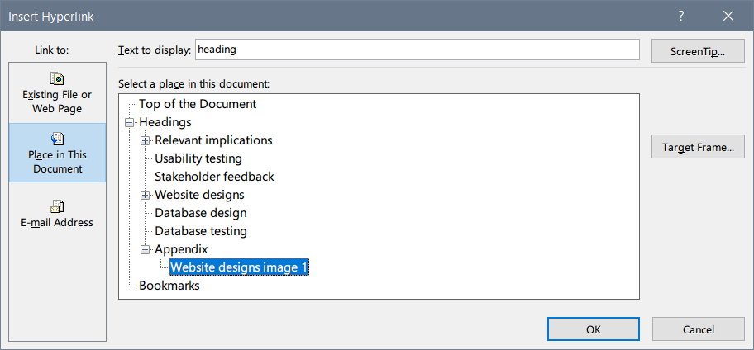
   4. Under Appendix, choose the heading you have just created and click OK.

## Example image: website designs image 1

Here is an example of a hyperlinked image. A link to it is included in the Website designs section. **DELETE THIS IMAGE BEFORE YOUR FINAL SUBMISSION**.

